Informal Source Reference in IEEE or ACM format:

Source :

Medium:

[1]A. Mohamed, “Handwritten Digit Recognition: A Beginner’s Guide - Abdelrahman Mohamed - Medium,” *Medium*, Oct. 20, 2023. https://medium.com/@AMustafa4983/handwritten-digit-recognition-a-beginners-guide-638e0995c826 (accessed Oct. 10, 2024).

Chat GPT:

[1]OpenAI, “ChatGPT ,” *ChatGPT*, 2024. https://chatgpt.com/

‌

‌

* Helpful Information/code/ideas/examples:

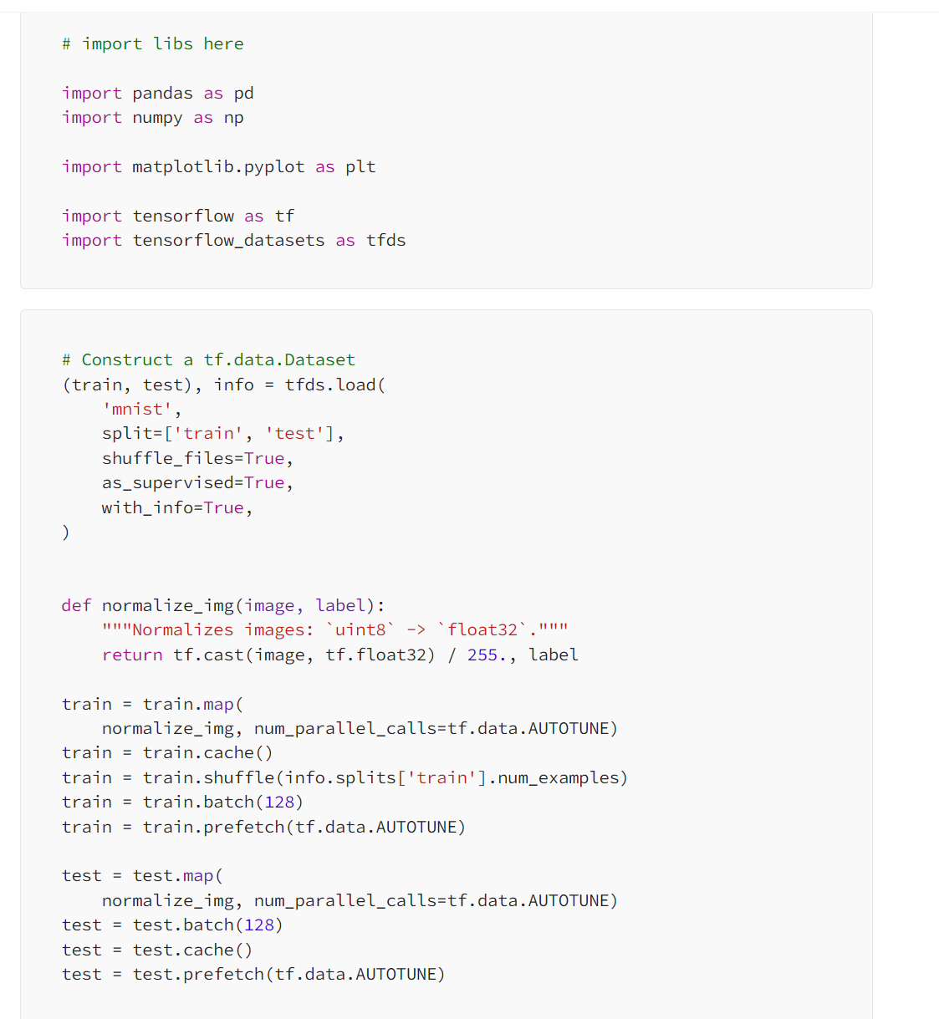

Code IDE platforms used: Tensorflow, Keras Pandas,Numpy and Matplotlib

Helpful information:

Preprocessing:

1. Utilizing a Normalizing function to standardize the data to avoid discrepancies and biases to influentialize the model within the data.
2. Batching - Storing Data to smaller subsets to avoid excessive memory usage

Caching - storing a copy of the data in RAM to be easily accessed and optimize the retrieval process

Prefetching - loading the data into memory for quicker data retrieval

Building/Training Model:   
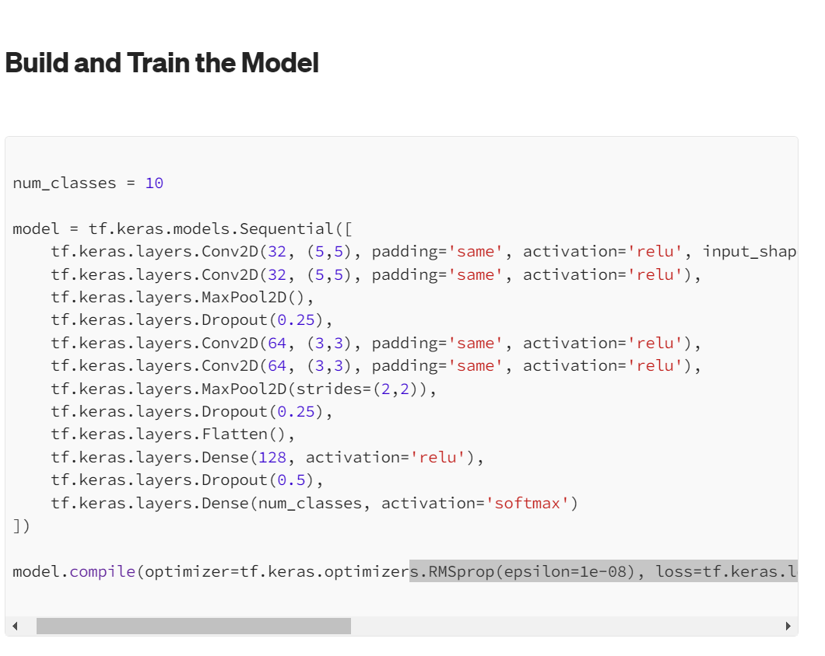

Helpful Information:

* Utilize Max pool layers to helping the model reduce spacial dimensions and to focus on more important features
* Utilizing 2D convolutional Layers with multiple filters to help the model learn hierarchical features which will help the model to learn complex figures and shapes/edges and help it in recognizing patterns

What the team would like to Learn from this resource:  
- Different pre-processing stages before model creation such as standardization and normalizing the data for avoiding biases

* Max pool/convolutional Layers that can learn complex figures and help in discovering patterns with different shapes and edges based on how the arraignment of pixels are.

Informal Source 2 Reference in IEEE or ACM format:

Source: [1]“A Beginner’s Guide to Keras: Digit Recognition in 30 Minutes - SitePoint,” *www.sitepoint.com*. https://www.sitepoint.com/keras-digit-recognition-tutorial/

‌

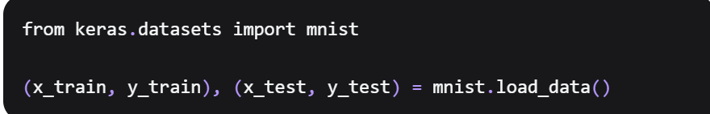

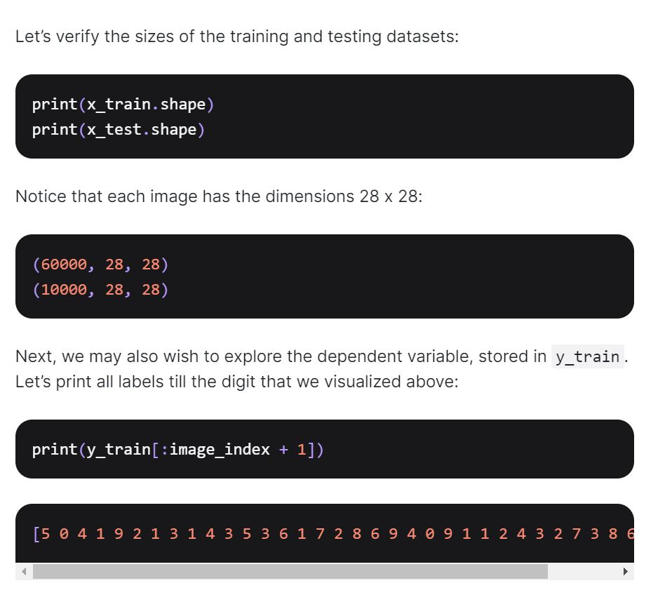

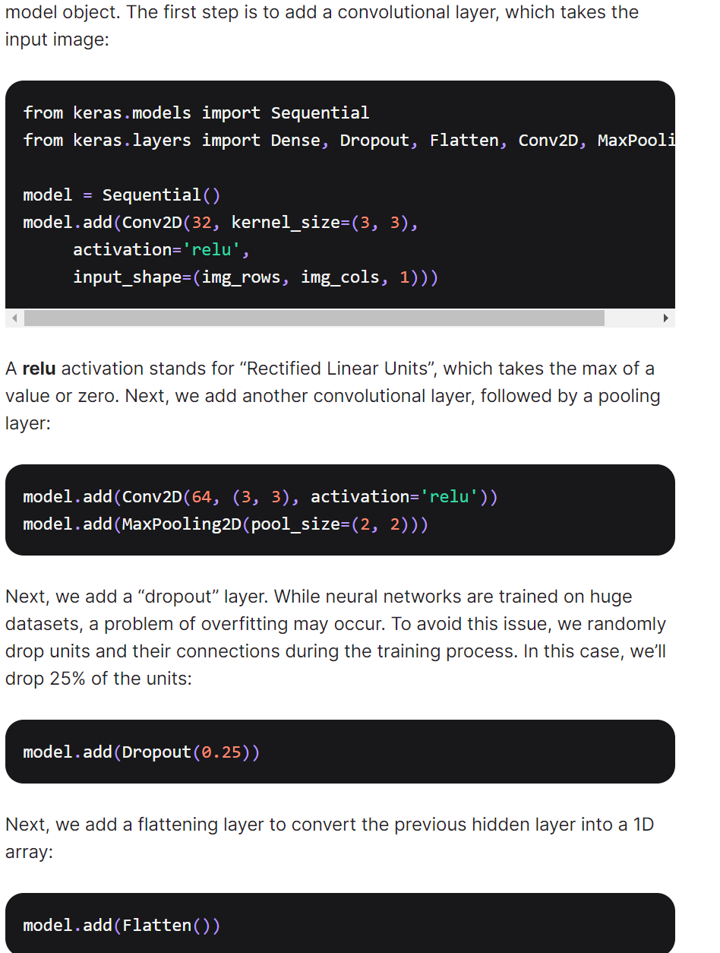

Helpful Information:

* Convoluted neural networks are arranged in a 3D array allowing for hidden layers to be connected to a small region in a vicinity allowing for a far more efficient than traditional neural network.
* Using Pooling layers, flatten layers and classification layers to help with feature reduction, dense layers expect input within a 1D format and important information is still accessible as spatial features are learned by earlier layers.

What the team would like to Learn from this resource:  
- Utilizing Convolution networks to allow for effective recognitive of textures and different shapes for understanding images and learning spatial hierarchies

* Dense Layers can learn more complex relationships and patterns with a flattened vector for more informed predictions of the data.